INTEGRATION TESTING

Main Module: SeasonTicketDAO.java

Import Classes:

* ISeasonTicket
* IUsageRecordFactory

Implemented Class:

* ISeasonTicketDAO

Number of methods: 6 and one constructor

Tested Status:

|  |  |  |  |
| --- | --- | --- | --- |
|  | | **Testing Status** | **Bug** |
| **Modules** | ISeasonTicketDAO.java | Done | 20 error |
| **Implement Class** | ISeasonTicketDAO | Done |  |
| **Import Classes** | ISeasonTicket  IUsageRecordFactory | Done |  |

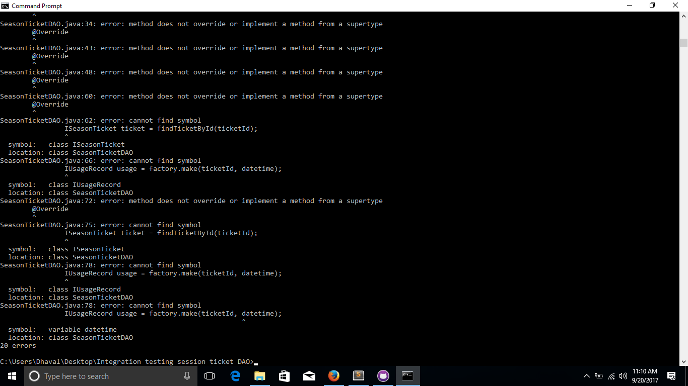

Prepared by: Lavina Patel